**Lesson 4 Demo 10**

**Understanding ReplicaSets**



Steps to be followed:

1. Creating ReplicaSets

**Step 1: Creating ReplicaSets**

* 1. Create a ReplicaSet configuration:

***vi singlereplica.yaml***

* 1. Add the following code in your yaml file:

***---***

***apiVersion: apps/v1***

***kind: ReplicaSet***

***metadata:***

***name: nginx-replica***

***namespace: twitter***

***spec:***

***replicas: 1***

***minReadySeconds: 10***

***selector:***

***matchLabels:***

***role: webserver***

***matchExpressions:***

***- {key: version, operator: In, values: [v1, v2, v3]}***

***template:***

***metadata:***

***name: web***

***labels:***

***role: webserver***

***version: v1***

***tier: frond-end***

***spec:***

***containers:***

***- name: web***

***image: nginx***

***ports:***

***- containerPort: 80***

***protocol: TCP***

***volumeMounts:***

***- name: webdata***

***mountPath: /usr/share/nginx/html/***

***volumes:***

***- name: webdata***

***hostPath:***

***path: /mnt***

***type: DirectoryOrCreate***

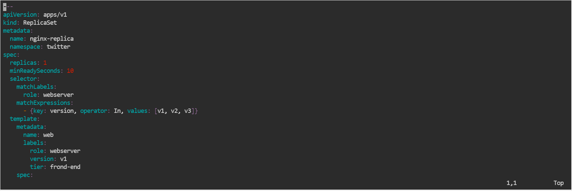

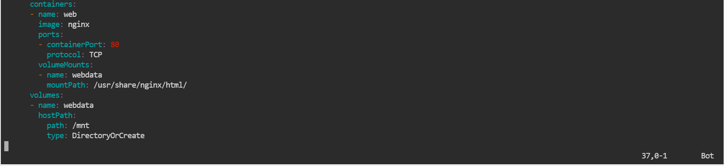

* 1. Create twitter namespace, if not present, using the following command (optional):

***kubectl create namespace twitter***

* 1. Execute the following command to configure the yaml file:

***kubectl apply -f singlereplica.yaml -n twitter***



* 1. Execute the following command to check the status of your pod:

***kubectl get pods -n twitter***

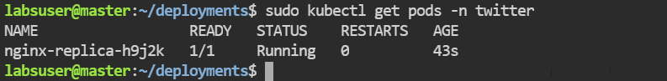

* 1. Execute this command to check the current ReplicaSet deployed and see the frontend you made:

***kubectl get rs -n twitter***

